

Topic : Online Voting System for Award Nominations.

Group no : MLB_PG.CURTIN.02_13

Campus : Malabe

Submission Date : 23/10/2020

We declare that this is our own work and this Assignment does not incorporate without acknowledgment any material previously submitted by anyone else in SLIIT or any other university/Institute. And we declare that each one of us equally contributed to the completion of this Assignment.

|  |  |  |
| --- | --- | --- |
| **Registration No** | **Name** | **Contact Number** |
| IT20062538 | Ravinda Anjana S.A.D | 0765929087 |
| IT20197278 | S.A.C.J.W Bandara | 0772502640 |
| IT20187200 | Dakumpitiya D.A.L.C | 0763478180 |
|  |  |  |
|  |  |  |

**CONTENTS**

1. HYPOTHETICAL SCENARIO 2
2. REQUIREMENT ANALYSIS 3,4
3. ER DIAGRAM. 5
4. RELATIONAL SCHEMA. 6
5. SQL COMMANDS TO CREATE DATA BASE TABLES.---- 7, 8
6. DATA INSERTION TO TABLES 9,10,11,12
7. SECURITY REQUIREMENTS 13

**Online Voting System for Award Nominations**

**Hypothetical Scenario**

Golden academy is an organization of performing arts specialized in Acting. It is established in the year 1980. Since then it has become a leading organization and an academy in the world in the field of arts. We have members all around the world who are experts in fields related to performing arts majorly related to the aspects regarding Acting. We use their expertise in the field of arts to improve the skills of the people who are into the field of art and expecting to build a career in the field.

"Golden Academy Awards" is an annual event organized by the academy with the collaboration of all our members around the world and people who are interested in the field of art. It is held to appreciate the excellence in Motion pictures and television series which were made in the previous year. Golden academy’s main goal of this award ceremony is to appreciate and honor the work that are related to the field of art and mostly value their services in their respective fields and also to inspire everyone to do more and more good things in the field

The Golden academy have an elite panel of judges to select the nominations for the voting process from the television series and motion pictures which were casted in the previous year. Golden academy has developed an online voting system for award nominations so that the members of the academy and the people all over the world can vote via the internet and view results accordingly. Registered members of the academy can vote in to both “BEST”,”POPULAR” categories and cast their vote. Guest users are only eligible to vote under the “POPULAR” category. Guest users first need to register to the system before casting vote. Member users can login to the system and cast their vote.

# Requirement Analysis

### Main Requirements

**Functional requirements**

-Judges need to select award categories for the award ceremony.

-Judges need to select suitable nominations for the selected award categories.

-Judges need to have the right to add/delete/modify award categories and its nominations.

-If there is any problem or issue judges need to contact the admin.

-After finalizing award categories and nominees judges need to handover them to the admin.

-Admin needs to publish award categories and nominees to the online voting system.

-There are two types of voters in the system.

-Guest voters first need to register to the system by providing their details such as name, email, contact no, address and giving a suitable password.

-Then guest voters need to log in to the system by using their provided email and password.

-Guest voters only eligible to view award categories and nominations of the “POPULAR” category in the online voting system.

-Guest voters can cast their vote according to their choice.

-If there is any issue or error guest voters need to contact the admin.

-Member voters are already registered in the system and they need to log in by providing their member ID and password.

-Member voters can browse both “BEST”,”POPULAR” categories and view award categories and its nominations and cast their vote.

- If there is any issue or error member voters need to contact the admin.

-Both guest, member voters can post their opinion, ideas about the award ceremony in the public comment section.

-Admin needs to display the voting instructions and rules and regulations to the voter before they vote.

-Admin needs to have the facilities of the add / update/ modify members or their information such as name, address, email, or phone number.

-Admin needs to Calculate the votes separately as normal votes and member votes and create results report. Report needs to have analysis like nominations that got highest votes, least votes and names of judges etc.

-Admin Needs to display results as award and next to that the winner as well as the number of votes they got, the results of the special award winners who decided by the judges.

**Non – Functional Requirements**

Non - functional requirements describe user visibility aspects of the system that are not directly related to the functional behavior of the system.

-Scalability – Any number of users can be able to access at the same time all the login and other details must store securely.

-Availability – 24 * 7 availability will be provided if there is internet connection.

-System modification – This system is flexible, but the only thing is all modification can be done by admin only.

-Security issues – The database in which all the information stored securely other than the admin others cannot access it. Also no one can login the site using others’ username and password.

**ER DIAGRAM**

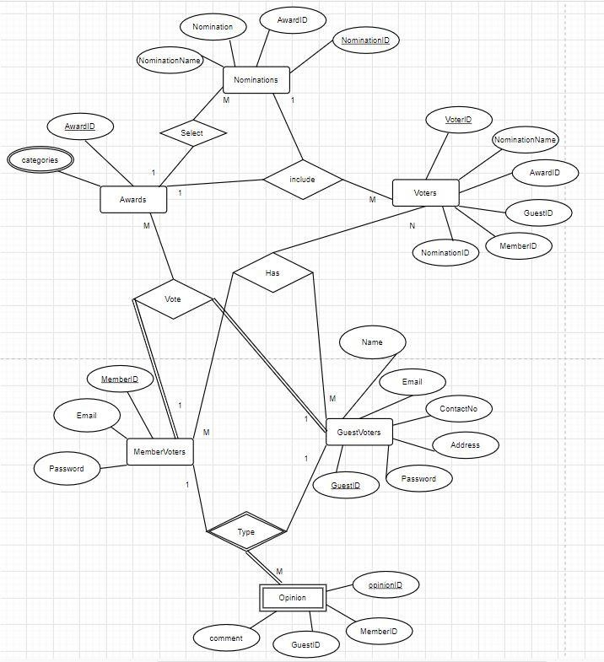

**RELATIONAL SCHEMA**

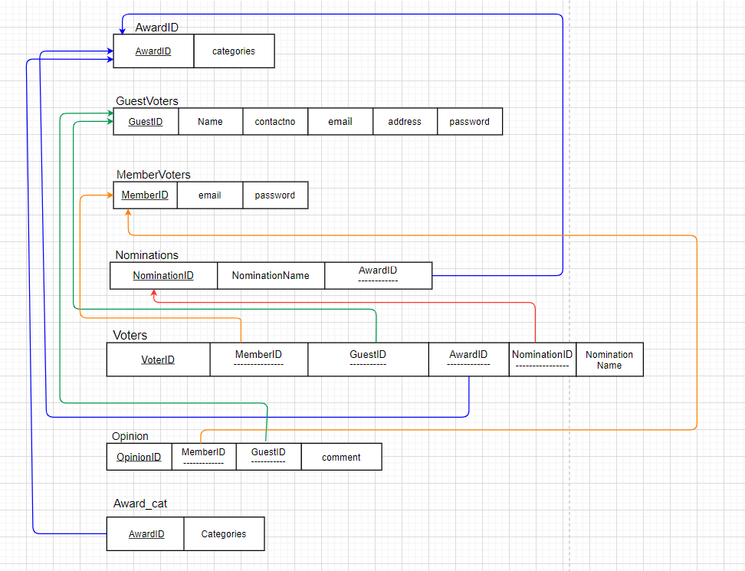

**SQL Commands to create database tables**

CREATE table Award (

AwardID varchar(10), Categories varchar(20),

CONSTRAINT ovs_pk3 PRIMARY KEY (AwardID)

);

CREATE table GuestVoters (

GuestID varchar(10), name varchar(30), contactno int not NULL, email varchar(30), address varchar(30), password varchar(20),

CONSTRAINT ovs_pk4 PRIMARY KEY (GuestID)

);

CREATE table MemberVoters (

MemberID varchar(10), email varchar(30), password varchar(20)

CONSTRAINT ovs_pk5 PRIMARY KEY (MemberID)

);

CREATE table Nominations (

NominationID varchar(10), NominationName varchar(20), AwardID varchar(10),

CONSTRAINT ovs_pk2 PRIMARY KEY (NominationID),

CONSTRAINT ovs_fk4 FOREIGN KEY (AwardID) REFERENCES Award (AwardID)

);

CREATE table Voters (

voterID varchar(10), MemberID varchar(10), GuestID varchar(10), AwardID varchar(10), NominationID varchar(10), NominationName varchar(20),

CONSTRAINT ovs_pk1 PRIMARY KEY (voterID),

CONSTRAINT ovs_fk1 FOREIGN KEY ( MemberID) REFERENCES MemberVoters (MemberID),

CONSTRAINT ovs_fk2 FOREIGN KEY ( GuestID) REFERENCES GuestVoters (GuestID), CONSTRAINT ovs_fk3 FOREIGN KEY ( NominationID) REFERENCES Nominations (NominationID)

);

CREATE table Opinion (

OpinionID varchar(10), MemberID varchar(10), GuestID varchar(10), Comment varchar(100),

CONSTRAINT ovs_pk6 PRIMARY KEY (OpinionID),

CONSTRAINT ovs_fk5 FOREIGN KEY ( MemberID) REFERENCES MemberVoters (MemberID),

CONSTRAINT ovs_fk6 FOREIGN KEY ( GuestID) REFERENCES GuestVoters (GuestID)

);

CREATE table Award_Cat (

AwardID varchar(10), Categories varchar(20),

CONSTRAINT ovs_pk7 PRIMARY KEY (AwardID),

CONSTRAINT ovs_fk7 FOREIGN KEY (AwardID) REFERENCES Award (AwardID)

);

## Data insertion to tables

insert into Award(AwardID,categories) values('A001','Best Picture'), ('A002','Best Actor'),

('A003','Best Actress'),

('A004','Best director'), ('A005','Best animated film')

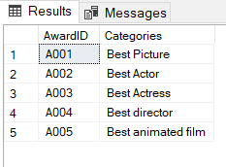

insert into GuestVoters(GuestID,name,contactno,email,address,password) values('G001','Saman Perera','0754789654','samanp@gmail.com','no10,Temple road,Colombo','srilanka123'),

('G002','Amal fernando','0774788654','amalf@gmail.com','no20,Church road,Kandy','India123'),

('G003','Kamal silva','0724789654','kamals@gmail.com','no30,Main road,Galle','Pakistan123'),

('G004','Sunil shantha','0774786654','sunils@gmail.com','no40,lotus road,Matara','Nepal123'),

('G005','Jehan vaas','0764789694','Jehanv@gmail.com','no50,Kovil road,Jaffna','Australia123')

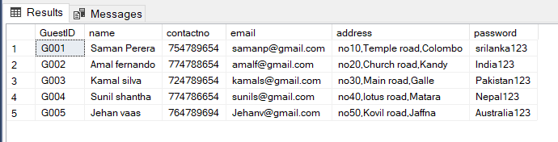

insert into MemberVoters(MemberID,email,password) values('M001','ruwand@gmail.com','Susipwan123'), ('M002','samithar@gmail.com','Syzygy123'), ('M003','kesiriw@gmail.com','Indeepa123'), ('M004','amithp@gmail.com','Sasip123'), ('M005','thamirah@gmail.com','Rotary123')

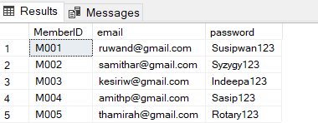

insert into Nominations(NominationID,AwardID,NominationName) values('N001','A001','joker'),

('N002','A001','parasite'),

('N003','A001','1917'),

('N004','A001','ford v ferrari'),

('N005','A001','jojo rabbit')

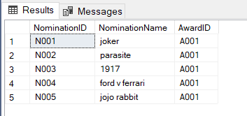

Insert into Voters(voterID,MemberID,GuestID,AwardID,NominationID,NominationName) values('V001','M001','G001','A001','N001','joker'),

('V002','M002','G002','A002','N002','Parasite'),

('V003','M003','G003','A003','N003','1917'),

('V004','M004','G004','A004','N004','Ford v Ferrari'),

('V005','M005','G005','A005','N005','Jojo rabbit')

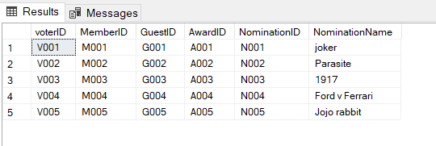

insert into Opinion(OpinionID,Comment) values('O001','There should be more awards'), ('O002','Good selections'),

('O003','Bad selections'),

('O004','Good nominees'),

('O005','Keep it going')

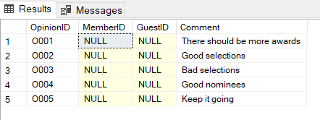

insert into Award_Cat(AwardID,Categories) values('A001','Best Picture'), ('A002','Best Actor'),

('A003','Best Actress'),

('A004','Best director'), ('A005','Best animated film')



## Security requirements

#### Registered member should be allowed to access to all the categories.

* Privacy of the user should be protected.
* Personal details of the user should be protected.